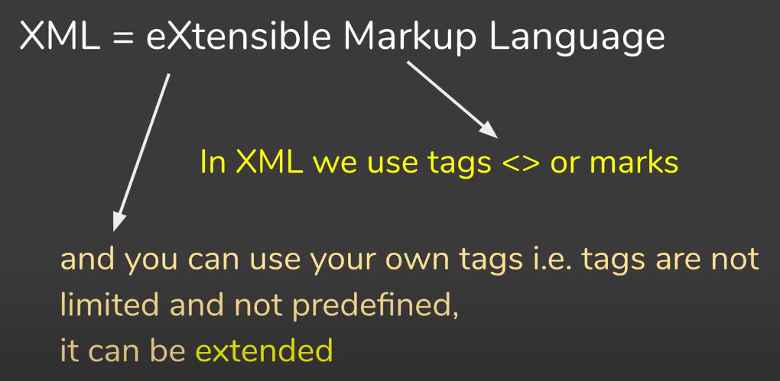

* XML Stands for extensible Markup Language.
* XML is a markup language like HTML
* It was designed to store and transport data. 🡪 message data storage 🡪
* XML is designed to carry data, not to display data.
* XML tags are not predefined. You must define your own tags.
* XML is platform independent and language independent
* Before yo start to learn XML, you should know basics of HTML & JavaScript.

-----------------------------------------------------------------------------------------------------

I have several hobbies. Reading,

painting, and gardening are my hobbies.

Cooking is my favourite pastime.

🡪This way of communication will work on two people are talking to each other

🡪However, if two machines are have to talk each other or exchange data each other this way of communication will not work

🡪So, we need more structured or more formatted way to exchange data using some common rules and syntax

🡪Let us try to convert this message into formatted way

<hobbiesList> 🡪tag or element we can place this <conical>

<hobby category="several">Reading</hobby>

<hobby category="several">Painting</hobby>

<hobby category="several">Gardening</hobby>

<hobby category="best">Cooking</hobby>

</hobbiesList>

Converted to json

{

"hobbiesList": {

"hobby": "Reading",

"hobby": "Painting",

"hobby": "Gardening",

"hobby": "Cooking"

}

}

<r>

<hobbiesList>

<hobby category="several">Reading</hobby>

<hobby category="several">Painting</hobby>

<hobby category="several">Gardening</hobby>

<hobby category="best">Cooking</hobby>

</hobbiesList>

<hobbiesList>

<hobby category="several">Reading</hobby>

<hobby category="several">Painting</hobby>

<hobby category="several">Gardening</hobby>

<hobby category="best">Cooking</hobby>

</hobbiesList>

</r>

<?xml version='1.0' encoding='UTF-8'?>

<employee>

<name>varun</name>

</employee>

* A simple element is an XML element that contains only text
* A complex element is an XML element that contains other elements and/or attributes

1. **Empty elements​**

< Empty a=“2"/>​

1. **Elements that contain only text​**

<Cashier Staff No='089'>Mary</Cashier>​

1. **Elements that contain only other elements​**

<PERSON Educ="Bsc" Uinv = "Tripoli">​

<SID>100</SID>​

<NAME>HASSE1</NAME>​

<ADDRESS>ADD1</ADDRESS>​

</PERSON>​

1. **Elements that contain both other elements and text​**

<Person>​

Address <State city="Jacksonville">FL</State> ​

</Person>​

<college>

<student>

<name>sofonias</name>

</student>

<faculty>

<name>varun</name>

<sub>mule</sub>

</faculty>

<hod college="gov" />

<principal> inder</principal>

</college>



